1. **Explore the highlights of the data that display information about the data.**

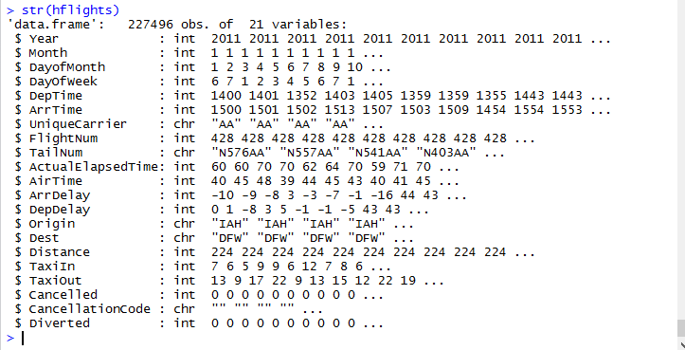

1. **Display the data on the first day of January for all years in the dataset.**

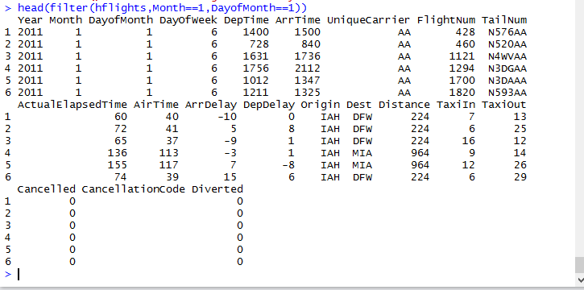

1. **Arrange your data in order of ArrDealy, Month, and Year using the arrange( ) function.**

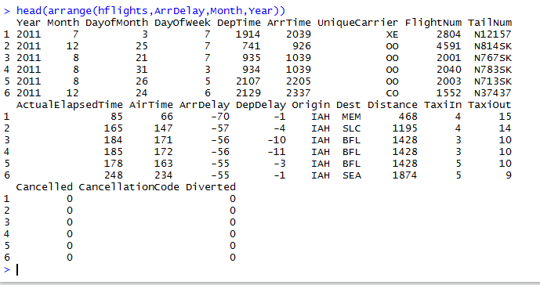

1. **Using the select() function, display the observations with only “Year,” “Month,” and “DayofWeek.”**

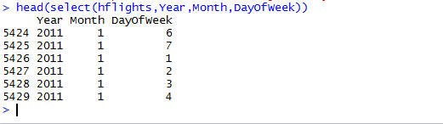

1. **Split the complete dataset into individual planes and then summarize each plane by counting the number of flights (count = n()) and computing the average distance (dist = 3 mean(Distance, na.rm = TRUE)) and arrival delay (delay = mean(ArrDelay, na.rm = TRUE)).**

